Project Design Phase
Problem – Solution Fit
Date | November 2026
Student Name | Rachabathula Gnana Sruthi
Project Name | Automated Network Request Management
Maximum Marks

Problem–Solution Fit
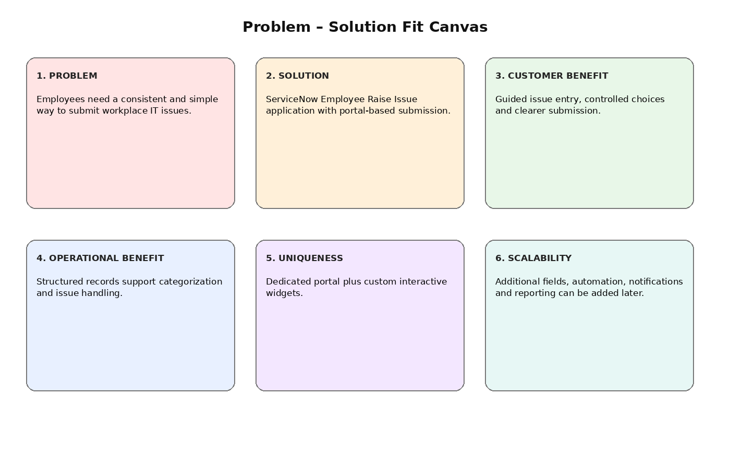
Figure 1: Problem–solution fit canvas adapted to the Employee Raise Issue project.
Parameter | Project Fit
Problem | Requesters need a consistent, structured way to submit network service and port access requests.
Solution | Automated Network Request Management application on ServiceNow with portal-based submission and Flow Designer.
Customer Benefit | Guided catalog items, fast validation, and clear status tracking.
Operational Benefit | Structured backend network records support rapid routing and audit-ready tracking.
Uniqueness | Combines ServiceNow scoped application with custom portal widgets and automated approval flows.
Scalability | Additional network types, automated notifications, and reporting dashboards can be easily added.

